**Creating Collectibles & Collecting Them**

**(This shows how to make items for your game and how to collect them)**

1. **Create a cube.**

GameObject—3D Object—Cube

Name the cube Item, Reset the position of the object and set position of the Y Axis to 0.5. Set the rotation of the object across all axis to a value of 30. Set the scale of the object to 0.3 across all axis.

1. **Create a script for the object.**

Select Object—Add Component—New Script—Name The Script Rotation—Open The Script From The Inspector Menu.

1. **The Script.**

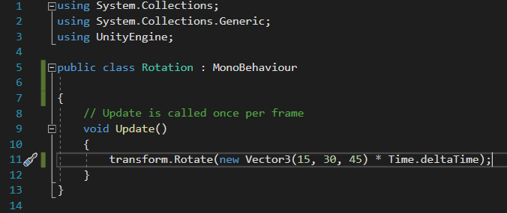

Line 11 Rotates the object to the values of 15,30 and 45 per second.

1. **Create a Prefab.**

Project—Deselect Everything—Create—Folder—Name the folder Prefabs.

Drag the Object (Item) from the Hierarchy of your scene into the Prefabs Folder you just created.

Create an empty game object and give it the name Items.

GameObject—Create Empty.

Drag the object named Item into the empty object we created named Items.

Select the object named Item within the Hierarchy, set the preview on Y axis and set the Item to Global mode.

Duplicate the Object (Item) by right clicking and pressing Duplicate and set it on the position you prefer.

1. **Add Material.**

Project—Create—Folder—Name the folder Materials.

Within the Materias folder, Right click—Create—Material.

Name the new material ItemColour and set it from the Main maps square box to a colour of your choosing.

Drag the ItemColour texture from the Project window to the Item asset located under Prefabs.

1. **Collecting Item of trigger.**

Open Your Player Script and add:

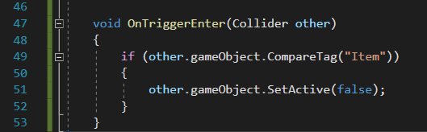

Line 47 Reference to the collider we encounter.

Line 49 We test its tag.

Line 51 If tag matches it deactivates the game object.

1. **Set Tag value for Items.**

Select Item asset from Project Window—Prefabs—Item

Go to Tag—Add Tag—Plus Button—Name it (Item)—and save.

Select again to the Item from the Prefabs folder and set the Tag to the tag you created named Item.

1. **Create a Rigidbody for our Items.**

Project Window—Prefabs—Item—Add Component—Rigidbody.

Tick the Is Kinematic box

Open Box Collider and tick the Is Trigger box.